1. Create policy number 1 which lets the users to:

a. Access S3 completely

b. Only create EC2 instances

c. Full access to RDS

2. Create a policy number 2 which allows the users to:

a. Access CloudWatch and billing completely

b. Can only list EC2 and S3 resources

3. Attach policy number 1 to the Dev Team from task 1

4. Attach policy number 2 to Ops Team from task 1

Soln🡪

Go to iam dashboard 🡪policies🡪 create policy

New popup will open 🡪fill the details

a)first select EC2 service and in actions allowed below permissions which we require to create ec2 instance.

"ec2:DescribeImages",

"ec2:AuthorizeSecurityGroupEgress",

"ec2:AuthorizeSecurityGroupIngress",

"ec2:DescribeInstances",

"ec2:DescribeVpcs",

"ec2:CreateSecurityGroup",

"ec2:CreateTags",

"ec2:DescribeInstanceTypes",

"ec2:RunInstances",

"ec2:DescribeSubnets",

"ec2:DescribeKeyPairs",

"ec2:DescribeSecurityGroups"

In resources select all

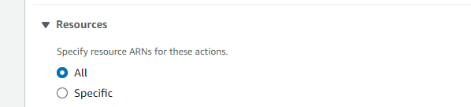

Now click on more permissions and give full access to RDS and S3.

Now for RDS

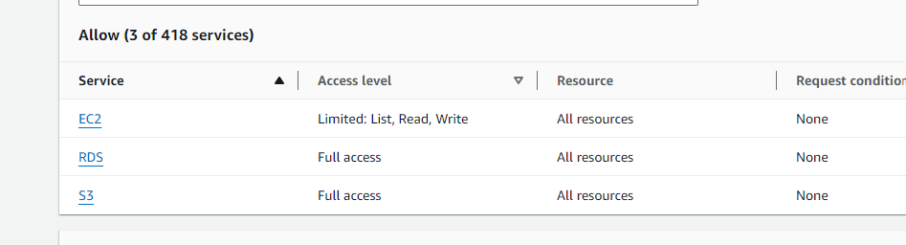

Now give policy the name number1. And create it.

Now lets createpolicy number2 with same way.

For listing EC2 instance

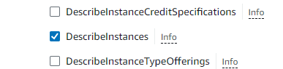

For Listing s3

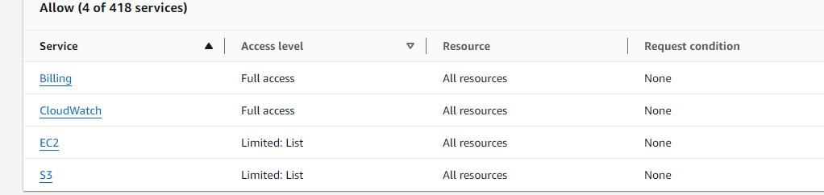

Now give the name this policy number 2 and create it.

Now let’s attach these policies to dev and ops team.

Go to policy one by one and permissions.

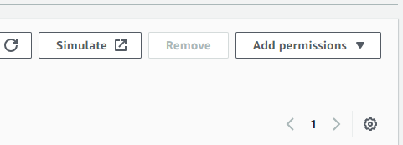

Attach policy now.

Same for ops team.

